## Create scripts

First create the following files in the Data Dictionary/Scripts directory

1. add-Collaboration-Folders.js
2. set-Searchable-contacts.js
3. set-contact-name.js
4. set-Searchable-sites.js
5. set-site-name.js

don't forget to set the mimetype to Javascript

## Collaboration Folder Actions

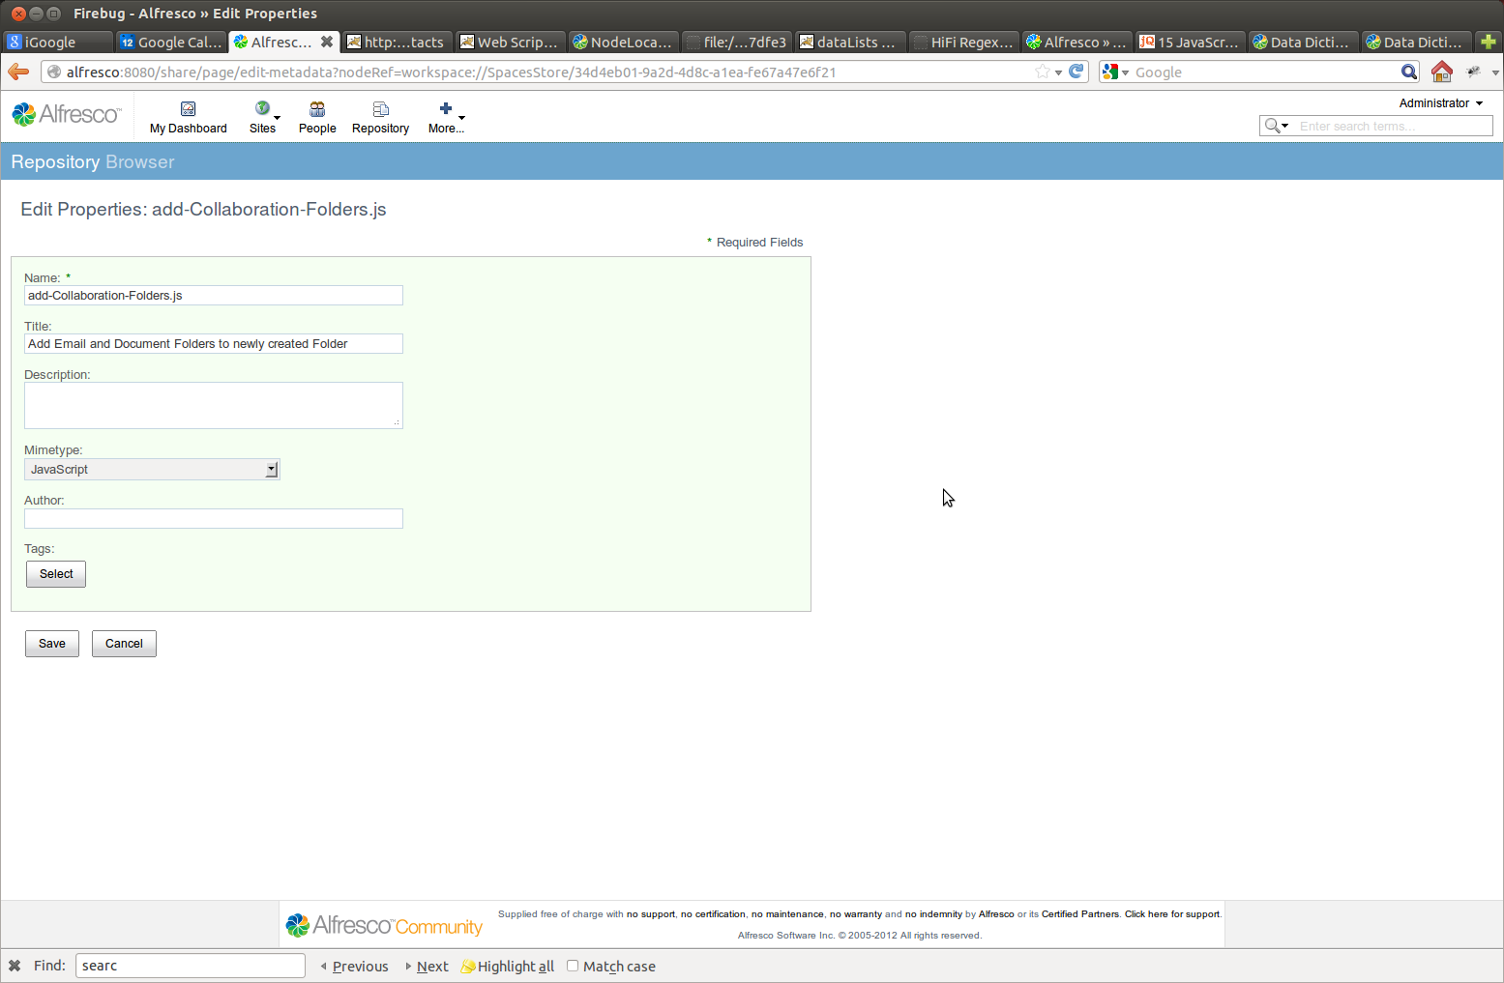

Then add rules to the Collaboration Folder –

1. On create folder
   1. one to change the type of an added folder
   2. Run add Collaboration Folders.js
2. On edit cm:collaborationFolder
   1. Run set Searchable contact.js
   2. Run set Searchable site.js

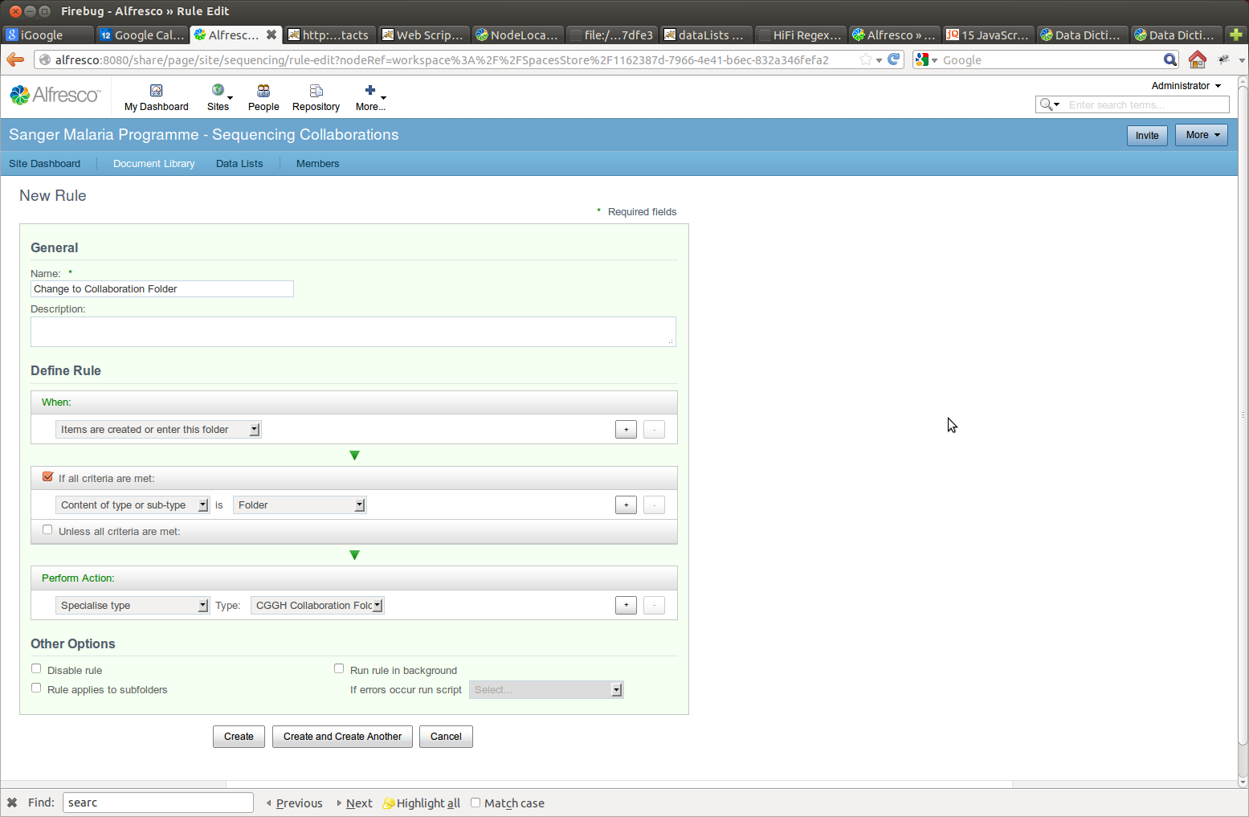

## Contact List

## Config

Use the java script console to set the name of the External Contacts List (Note the _ instead of space)

document.name = 'External_Contacts';

document.save();

## Actions

Via the Repository view set the script set-contact-name.js to run on all create/update actions in the External Contacts List.

## Site List

As above